Modeling:
Mathematics:
Programming:
Science:

Software Lab:
AI-supported Automated Feature Recognition

Description

Industry 4.0 and smart manufacturing aims to ensure high degree of automation and digitization by incorporating AI driven perception and decision-making in semi-automated or fully automated robotized factories.

During the production design process, Computer-Aided Design (CAD) and Computer-Aided Manufacturing (CAM) have been the primary form of product design, guiding all the subsequent manufacturing automation. Furthermore, automated feature recognition (AFR) is the first and the most important step in the process of translation of CAD information into some instructions appropriate for intelligent manufacturing. It is also essential for a fully automated tightly coupled CAD and CAM development.

However, in spite of large research efforts, contemporary automated feature recognition systems still suffer from many disadvantages, due to the complexity of the „classical“, e.g. rule-based or graph-based recognition algorithms [2]. Artificial intelligence driven methods and data driven methods have exhibited improved performance here, especially in the case of feature extraction and recognition, feature mapping, geometry segmentation and geometry analysis.

This topic aims to investigate feature extraction and recognition on 3D surfaces defined either as CAD models or as 3D triangular meshes. The extracted features can lead to surface segmentation and analysis so as to guide subsequent process modelling and decision making on manufacturing, e.g. which manufacturing process to use and with what parameters.

Close collaboration will take place with TEBIS [3], a specialist in Computer-Aided Design/Manufacturing (CAD/CAM) and Manufacturing Execution System process solutions - in machine, die and mold manufacturing. TEBIS will provide consulting and training data for the developed algorithms.

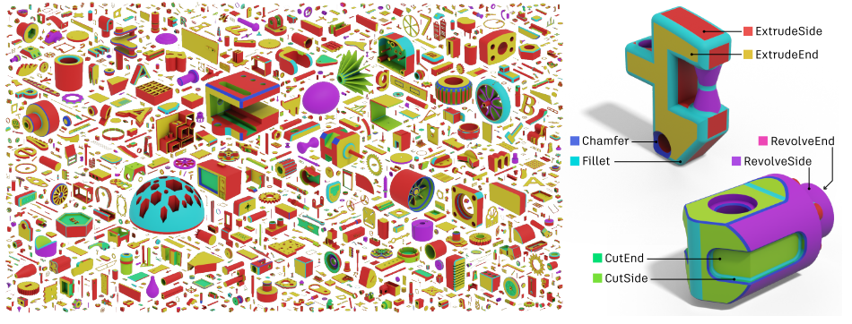
Figure 1 BrepNet: A topological message passing system for solid models[1]

Task

- Introduction to geometric deep learning and 3D feature recognition
- Introduction to deep learning and machine learning algorithms and frameworks
- Preprocessing of data input for feature recognition
- Implementing of relevant data-driven algorithms 3D geometry segmentation and feature extraction
- Comparing results from different AI and data-driven approaches

Supervisor
Dr. Stavros Nousias, Chair of Computational modelling and Simulation, TUM, stavros.nousias@tum.de
Dr. Jovana Knezevic-Sorger, Tebis Technische Informationssyteme AG, jovana.knezevic-sorger@tebis.com

References
[1] Lambourne, J.G. et al. (2021) ‘BrepNet: A topological message passing system for solid models’, Proceedings of the IEEE Computer Society Conference on Computer Vision and Pattern Recognition, pp. 12768–12777. Available at: https://doi.org/10.1109/CVPR46437.2021.01258.
[2] Babic, Bojan & Nesic, Nenad & Miljković, Zoran. „A review of automated feature recognition with rule-based pattern recognition.“ Computers in Industry. 59. 321-337. 10.1016/j.compind.2007.09.001 (2008).
[3] https://www.tebis.com/en

