Modeling:
Mathematics:
Programming:
Science:

Software Lab:
Automatic space utilization and activity recognition using point cloud and RGB images

Description

The digitization of building structures through the creation of semantic digital models has become a crucial tool in the Architecture, Engineering, and Construction (AEC) industry. A digital twin, which provides a virtual replica of physical assets, finds various applications across urban planning, architecture, facility management, and emergency response. Despite advancements in the automatic creation of digital building models with rich semantic and coherent geometry, automatically inferring semantic information about building spaces remains a challenging task.
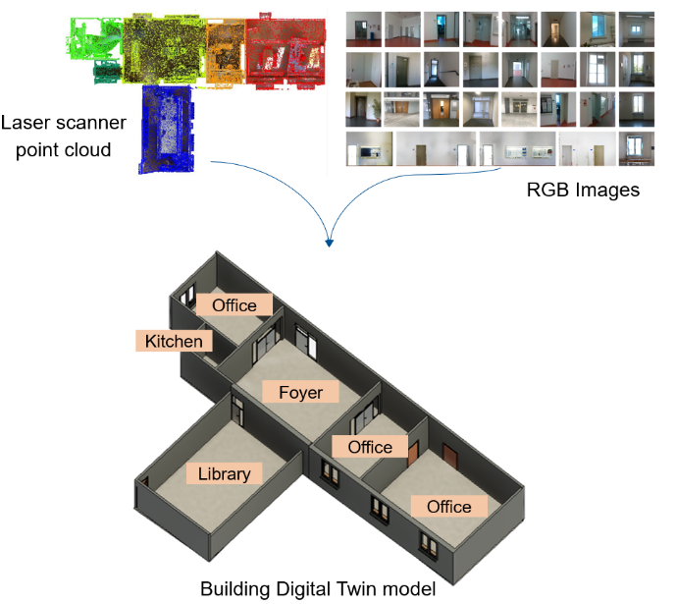
Automatic recognition of space utilization such as offices, kitchens, libraries, etc., within digital building models offers a transformative approach to creating and utilizing digital models for understanding and optimizing the built environment. Precise semantic information enables efficient monitoring and assessment of structural elements, leading to proactive maintenance strategies and the overall prolongation of a building's lifespan. The aim of this project is to develop an automatic algorithm for recognition space utilization and activity within the built environment using laser scanner point clouds and RGB images [1]. The proposed pipeline takes advantage of artificial intelligence techniques in scene understanding and combines them with domain knowledge to derive the rules and information required for classifying spaces based on their utilization [2].

Task

Develop an automated algorithm for recognizing space's utilization within the built environment using laser scanner point clouds and RGB images:
- Literature review on valid approaches and AI network architectures for object detection, semantic segmentation and classification on point cloud and image datasets.
- Annotation of point cloud and image datasets required for training AI networks.
- Extract domain knowledge in engineering to establish the rules and information required for classifying spaces based on their utilization.
- Implementation with a prototypical case study (TUM campus) and evaluation of results.

Supervisor
Mansour Mehranfar (mansour.mehranfar@tum.de), TUM Chair of Computational Modeling and Simulation
References
- Das, Anooshmita & Jens, Krister & Kjaergaard, Mikkel. (2020). Space Utilization and Activity Recognition using 3D Stereo Vision Camera inside an Educational Building. 10.1145/3410530.3414318.
- Cheng, Jieren & Li, Hua & Li, Dengbo & Hua, Shuai & Sheng, Victor. (2023). A Survey on Image Semantic Segmentation Using Deep Learning Techniques. Computers, Materials & Continua. 74. 1941-1957. 10.32604/cmc.2023.032757.

