Modeling:
Mathematics:
Programming:
Science:

Software Lab:
Augmented reality for quality assessment of timber boards
Description

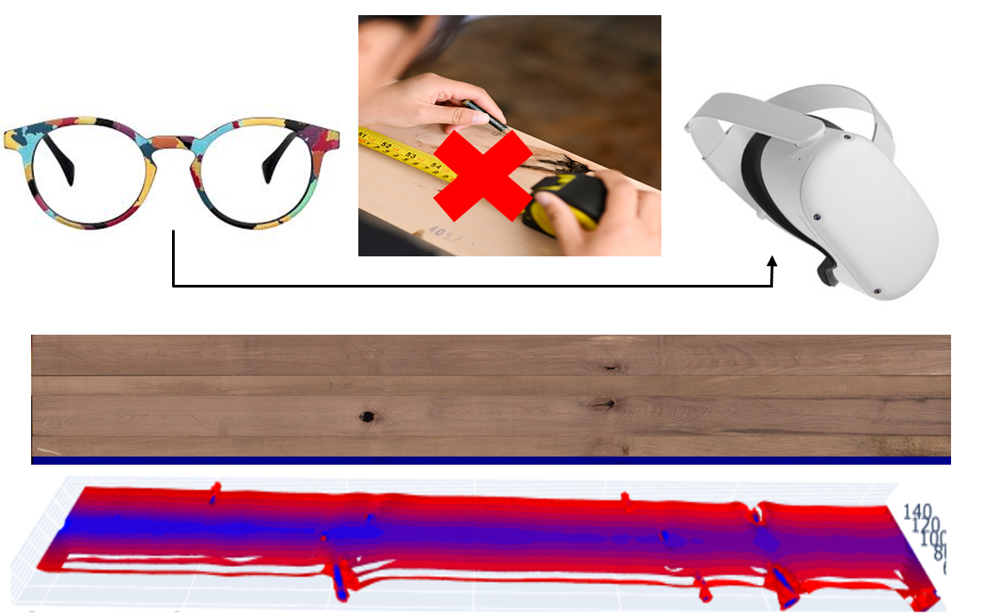
Evaluating mechanical properties of timber boards is an important task for the growing usage of this material in engineering application. Due to the high natural scatter of this material as well as its high amount of anisotropy and heterogeneity, different technologies should be used for evaluation of this material. Up to now this process is done manually, by measuring the coordinates of each imperfection at the lab. One possible way for reconstruction of timber boards is the usage of glasses. So the normal glasses can be replaced by augmented reality glasses !

Task

- Evaluation of the images/videos from the glasses
- Registration of the imperfections
- 3D-Reconstruction of the boards with imperfections

Supervisor
Andriy Kovryga, Wood Technology, kovryga@hfm.tum.de
Ani Khaloian, Wood Technology, khaloian@hfm.tum.de
Prof. Jan-Willem van de Kuilen, Wood Technology, vandekuilen@hfm.tum.de

