Modeling:
Mathematics:
Programming:
Science:

Software Lab:
Building Integration and Graph Analytics:
A Digital Twin Approach using Labeled Property Graphs
Description

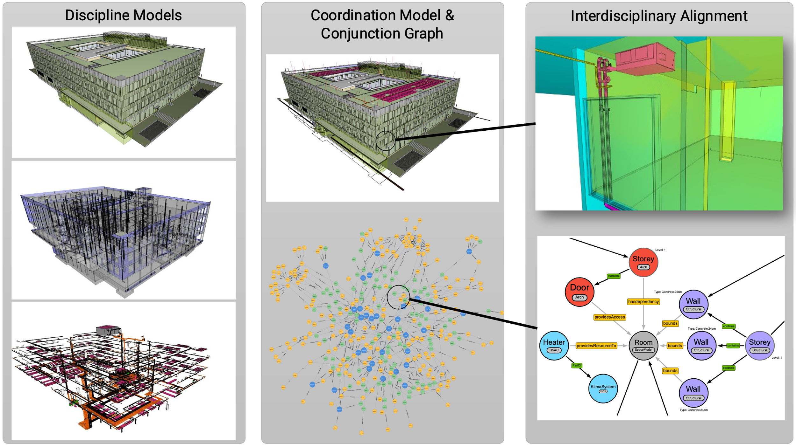
This software lab aims to integrate diverse Industry Foundation Classes (IFC) models from various disciplines of one building, focusing on creating a digital twin. The key objective is to merge geometry considering the IFC topology while also accounting for geometry adjacencies. Subsequently, students will prepare a graph-meta model that unites information and geometry to support the creation of a comprehensive Labeled Property Graph (LPG). The graph will represent an extensive dynamic virtual representation of the building. The final phase involves leveraging graph data science tools to query room-specific or floor-specific details, determine model discrepancies, and adeptly manage obsolete information within the context of the digital twin. This hands-on investigation aims to deepen students' comprehension of BIM integration, graph database analytics, and the powerful concept of a digital twin, highlighting the intricate connection between spatial data and advanced graph structures.

Task

This software lab utilizes Solibri, Ifcopenshell, and other tools to extract and interact with adjacencies from diverse IFC models. Participants will then use CYPHER to integrate this data into a comprehensive graph, utilizing Neo4j and the Graph Data Science library for construction and exploration.

GENERAL INSTRUCTIONS:
- Understand IFC standards and essential BIM concepts.
- Employ suitable programming languages and libraries for geometry processing.
- Leverage Neo4j for effective graph database implementation.
- Experiment with Cypher queries and Neo4j Graph Data Science Tools for comprehensive graph data science.
- Highlight the importance of querying and managing data for informed decision-making in complex spatial structures.

Supervisor
Fabian Pfitzner & Sebastian Esser, TUM CMS

