Modeling:
Mathematics:
Programming:
Science:

Software Lab:
Vectorization of technical drawings using Deep Learning

Description
Technical drawings, often in the form of floor plans, are required to design, define, and execute a building project. Still, it is becoming increasingly common to develop 3D models of the building defined in floor plans since it allows to perform simulations, spot structural flaws, and easily visualize the final result. The modeling task is not automatic; it requires less time and effort if the drawings are in a vector format, but often it is the case that the floor plan is rasterized, which means that the drawing is transformed into an image from the vector format in which it was produced, all the semantic information contained in the drawing are lost in the pixel transformation. Retrieving the lost semantic information frequently involves professionals in reconstructing the floor layout; it is time-consuming and prone to errors.
The focus of the topic is to develop a robust and reliable automatic vectorizer from scans of technical drawings using deep learning models. To obtain precise results cleaning of the noise in the image and optimization of the geometries need to be taken into consideration.

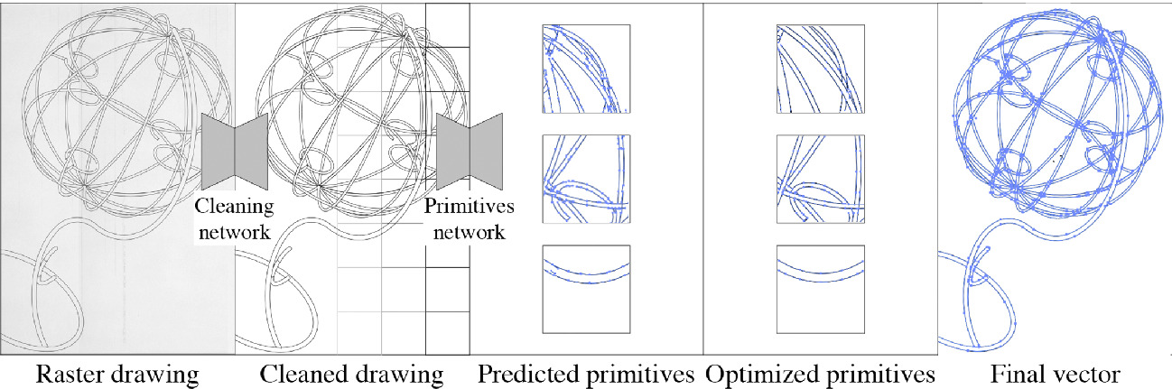
Image 1: Example of vectorization pipeline. [1]

Task
GENERAL INSTRUCTIONS:
- Literature research on the topic
- Dataset definition
- Comparison of existing AI methods and rule-based methods for cleaning and vectorization of the scan
- Training / fine-tuning on real-life scans
- Assessing results

Supervisor
Andrea Carrara, CMS (TUM), andrea.carrara@tum.de

References
[1] Egiazarian, Vage, et al. "Deep vectorization of technical drawings." European conference on computer vision. Cham: Springer International Publishing, 2020.

